**A guide to using CLIC to analyze wing shapes**

A general process for using CLIC_99:

1. Digitize landmarks using **COO**
   1. Input files- GIF files of wings
   2. Output files
      1. *Coord_MonthDay.txt*-The coordinates of your recent landmarking.
      2. *coordLast.txt*-A log of time and date of landmark coordinates.
2. Transform your data file so that each row contains all the coordinate information for one individual with **TET**
   1. Input file (“source file”)- Text file of landmarks (ie *Coord_MonthDay.txt*)
   2. Output files
      1. *Coord_MonthDay_Format.txt*- Formatted file, first line with info, no ind. info
      2. *Coord_MonthDay_Format.nts*-File that can be used in TPS
      3. *Coord_MonthDay_DB.txt*-Formatted file with path, id, comment etc. information
3. Scale landmarks with Excel (convert Pixels=unites of measurement)
   1. Excel is an easier way to visualize your data and to scale it correctly.
   2. Make a new .txt file with your scaled data with only the coordinates (no column/id) info.
4. Do the Procrustes superimposition (Translation, rotation, rescaling), compute partial/ relative warps and centroid size (CS) with **MOG** on the raw, scaled data
   1. Input file- Text file with scaled raw data made with Excel in step 3. (*Raw scaled data.txt)*
   2. Output files
      1. *Raw scaled data_CS.txt*- Centroid sizes
      2. *Raw scaled data_TRANSCALED.txt* -
      3. *Raw scaled data_ALIGNED.txt*
      4. *Raw scaled data_ProcrRes.txt*
      5. *Raw scaled data_PW.txt*
      6. *Raw scaled data_RW.txt*
      7. *Aligned_consensus.txt*
      8. *Aligned_consensus_vect.txt*
      9. *Raw scaled data_PW_CS.txt*-File with PW and CS, used in COV for allometry
      10. *Raw scaled data_MOG_INFO.txt*
      11. *Raw scaled data_ProcrRes.nts*
      12. *Raw scaled data_ProcrRes_TOTAL.txt*
      13. *Raw scaled data_PW_CS.nts*
5. Test for allometry using **COV**.
   1. Input file (“source file”)- Text file of landmarks (ie *Coord_MonthDay.txt*)
   2. Output file- *Raw scaled data_ProcrRes.nts*
6. Compare centroid size (means and variance) between groups with **VAR**
   1. Input file (“source file”)- Text file of centroid sizes (ie *Coord_MonthDay_CS.txt*). Can have list of groupings in an excel file and the first line of the text file with the groupings so you can remember them.
   2. Output file- *Coord_MonthDay_CS _INFO_VAR.txt*
7. Metric Disparity with **COV**
   1. Input file- *Coord_MonthDay_scaled-raw.txt*- Your raw but scaled coordinates.
   2. Output files
      1. *Coord_MonthDay_scaled-raw_INFO_COVmd.txt*- Has results of MD calculation
      2. *Coord_MonthDay_scaled-raw.nts*- A file that can be used for TPS
8. Principal coordinates analysis (PCA) with **COV**
   1. Input file- *Coord_MonthDay_PW.txt*
   2. Output files
      1. *Coord_MonthDay_PW_INFO_COVpca.txt*- Your results
      2. *Coord_MonthDay_PW_PC.txt*-Partial warps calculated from PCA
      3. *Coord_MonthDay_PW.nts*- File for use in TPS
9. Tree analysis with **COV**
   1. Input file- *Coord_MonthDay_PW.txt*

Before getting started, you should confirm that your wings are in a similar orientation. Your images can easily be manipulated in a free software such as ImageJ.

**1. Digitizing landmarks and acquiring landmark data**

**COO**

1. COO opens to last used folder where you will select image files for landmarking  
   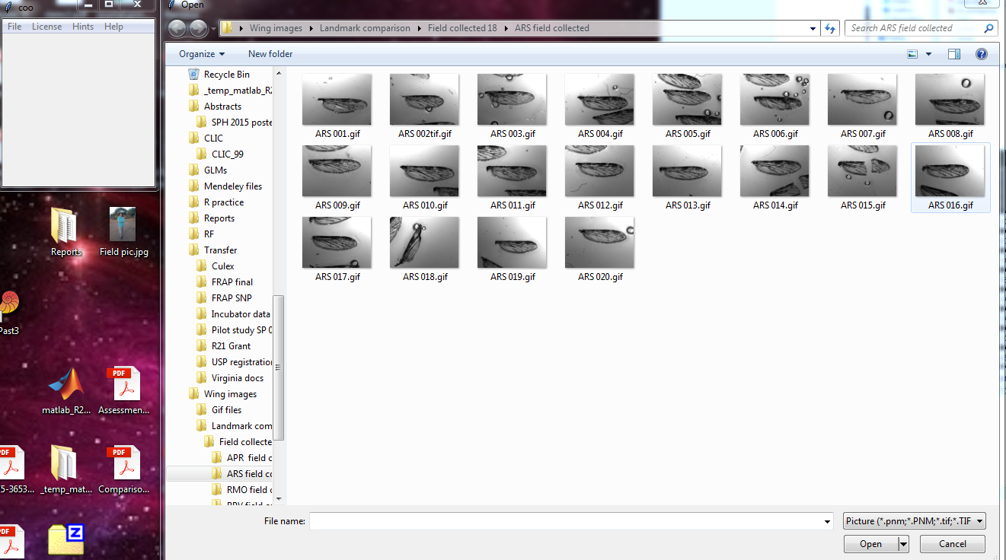
2. Select a file and then COO opens it up. CLIC toolbar key:(From left to right)  
   1. Get new image  
   2. Run, start getting landmarks  
   3-7. Rotate image around  
   8. Magnify  
   9. ?  
   10. Change cursor type  
   11. Erase  
   12. Ruler for scaling (not needed for landmarks)  
   

1 2 3 4 5 6 7 8 9 10 11 12

1. Click the “Running man” to begin. 
2. Select landmarks in sequence.  
   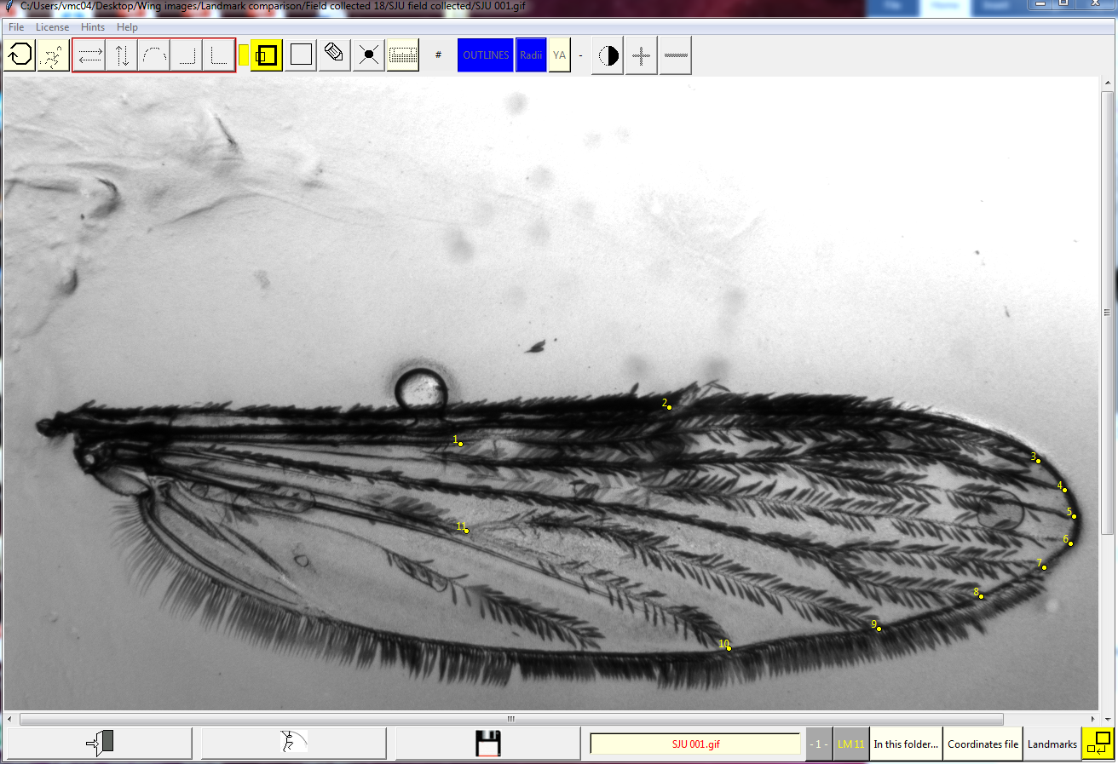
   1. If you make a happy little accident, click the erase button or “e”
3. When you are done, click save (floppy disk)  
   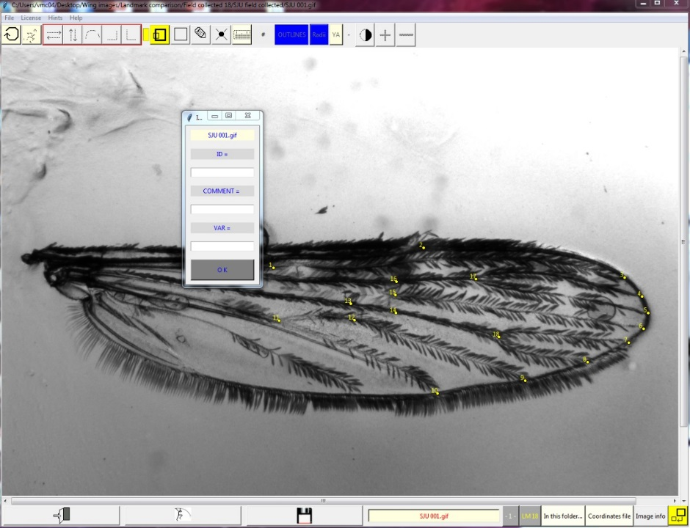
4. Save landmarks- ID=SJU001, Comment= 13 or 18 landmarks
5. When you are all done, close the program by going File-> Exit
6. Find the .txt file. Should be something like “coordLast.txt” or “coord_May08.txt”
7. The data will be laid out as such as raw coordinates:  
   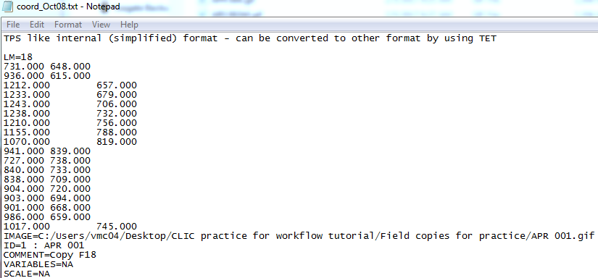
8. A more useful layout will be Id x1 y1 x2 y2… which can be accomplished with TET.

**2. Transform data with TET**

1. TET opens to last used folder in CLIC, where you will select your input text file.  
   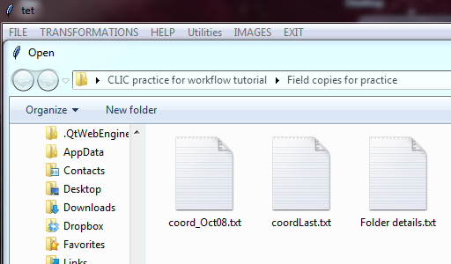
2. After selecting the file, a popup will appear. Since these are raw coordinates, click “Yes”.  
   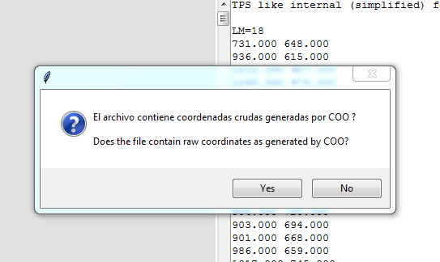
3. Another popup will ask about a first transformation and click “Yes”.
4. Then there will be a popup summarizing what you just transformed.

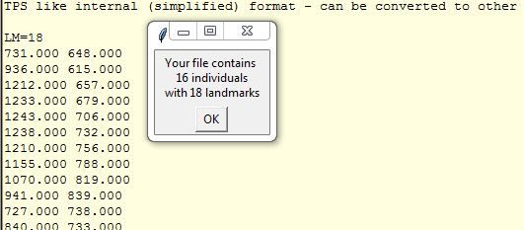

1. Now you will have 3 output files: *Coord_MonthDay_Format.txt, Coord_MonthDay_Format.nts, Coord_MonthDay_DB.txt*

**3. Put data into Excel**- At this point, unless you set a scale, you have created raw, unscaled data. Raw because it has not yet been translated, rotated, or rescaled yet. Unscaled because the coordinates are in pixels, not in your units of measurements, like mm.

Copy the contents of the *Coord_MonthDay_DB.txt* file and scale by transforming pixels to millimeters with your known scale. Copy the mm coordinates to .txt file (with no column or identifier information). In the first row of the .txt file, you can copy the number of specimens per group and other information related to the file. The next software will overlook the info on the first row (i.e. 12 18 20 Brazil Colombia Venezuela 18 LMs). Now, you have *raw scaled data*.

**4. Procrustes analysis to generate partial warp data**

**MOG**

1. Open the MOG package in CLIC.
2. Open the .txt file (*raw scaled data*) that you just made from the above Excel scaling in MOG.
3. Enter the group sizes, with spaces between each separate group/classification.  
   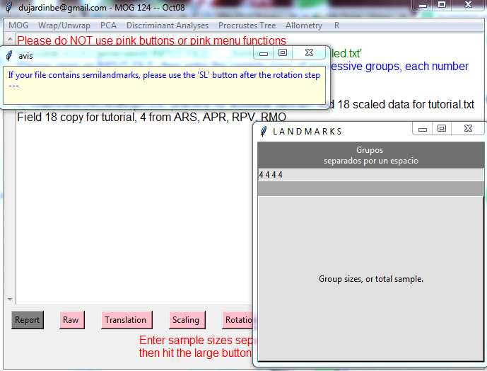
4. Follow the green highlight to translate, scale and rotate the landmarks.

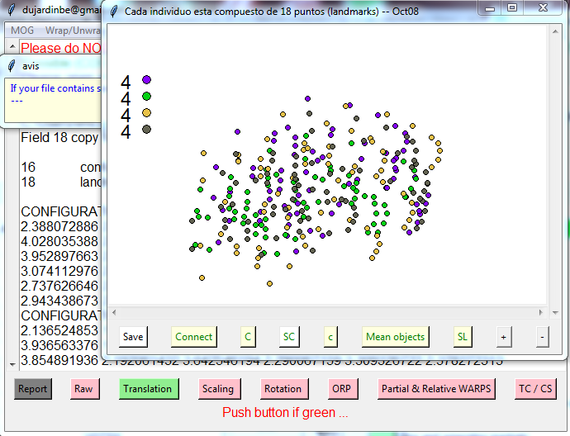

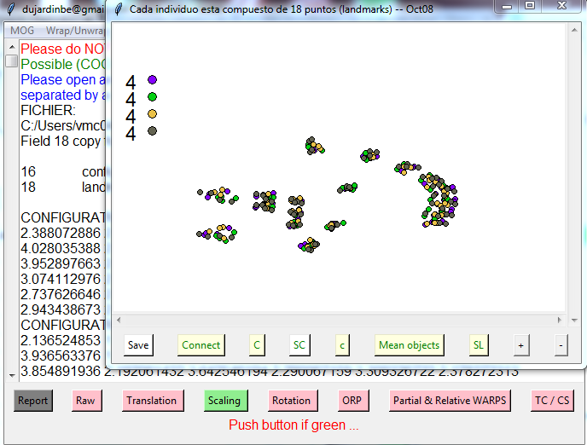

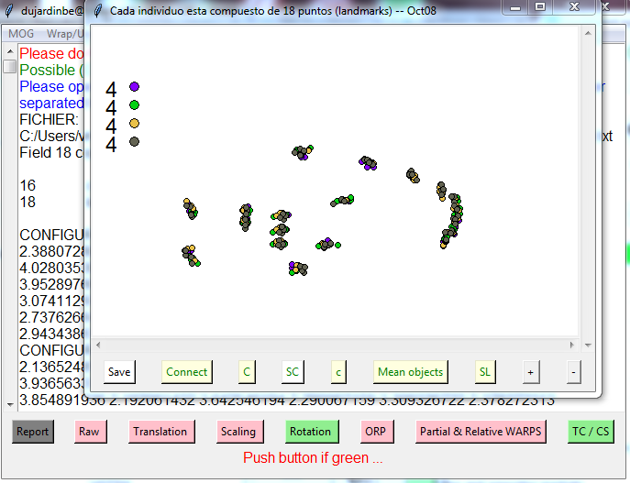

1. After rotation, there is a popup stating which files have been made.  
   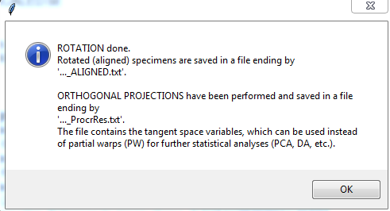
2. Click through to get partial and relative warps.



1. If you click on TS/CS you get a graph of your data.  
   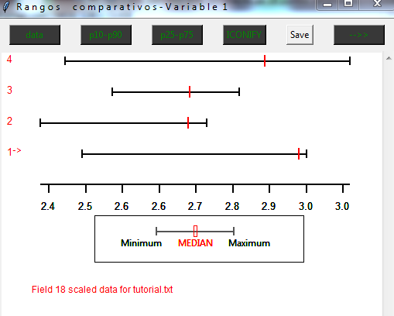
2. You can save all the results by clicking on “Report” when it turns green.
3. Now there are a bunch of .txt files from your MOG computations. The ones with “_PW” have principal warps. There should be (# of landmarks*2)-4= total # of PWs. Files for “_CS” have the calculated centroid sizes.   
   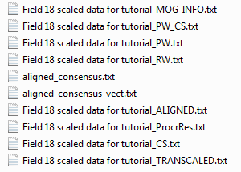
4. Test your CS values for normality. This can be done in many ways, such as R, PAST3 and STATA. This will help determine which type of statistical analysis like parametric (ANOVA) or non-parametric (Kruskal-Wallis) is most appropriate.

**5. Test for allometry (shape affecting size) with COV**

1. We want to figure out if there is an allometric effect. Do bigger individuals have different shapes simply because of a larger size?
2. Open the COV package in the CLIC program. Your input files need to be based by group and one .txt for each group. You might need to copy and paste your data into separate text files if they are store together.
3. Click Allometry-> Different versus common slope allometric model –> 1000 permutations. Choose the appropriate PW_CS.txt output file and indicate groups (i.e. 12 18 20). If you can’t read all the data lines, click “Wrap”.  
   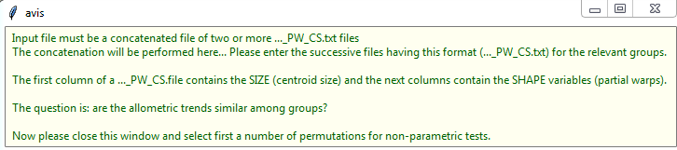
4. You can save your results by clicking “Report”. A p-value <0.05 indicates a significant allometric effect.
5. Under multivariate regression result you will see Euclidian distances with Bonferroni correction and a text that indicates that after Bonferroni correction, just those values <XXX should be considered as significant.
6. If you find a significant allometric effect, the next question is if this effect is the same in each group (pop/species) –you should check in the output file on COV the Wilks lambda result to know if you can correct the effect (Wilks lambda compares the slopes among groups-if they are similar, you can correct the effect, if not it could not). A Wilks lambda value <0.05 means that effect cannot be correct. In contrast, a value >0.05 indicated that it could be correct and COV offers a button to do the correction.

*Note*: when you are working with population comparison (same species) some authors suggest that allometric effect is negligible and is a biological property of the species and so, it should not be corrected. However, when you are comparing different species, it is a requirement to test this. Usually, different species have different growth patterns and this effect should be measured. See (Outomuro and Johansson, 2017)

**6. Compare centroid size (means and variance) between groups with VAR**

1. Make sure your “…_CS.txt” file looks like this with 1 comment line (the 1st line) and then your CS values.  
   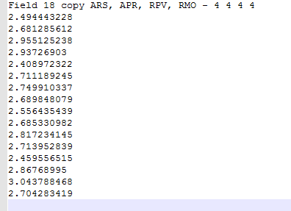
2. Open the VAR package of CLIC and select this file.
3. Enter the proper groupings for your file, with a space between each (ie “4 4 4 4”).  
   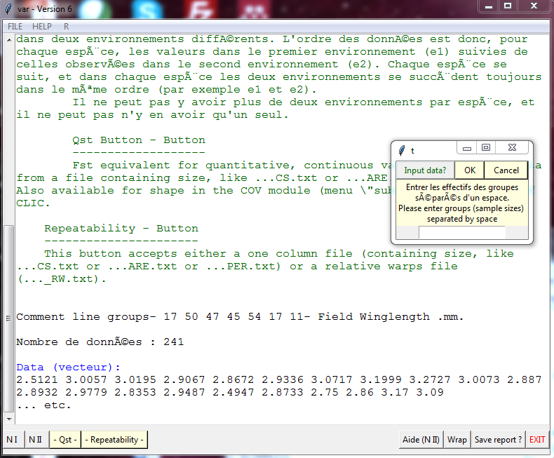
4. Select “N I” for non parametric comparisons of size  
   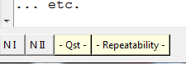
5. A box appears and type in how many permutations (ie 1000)  
   
6. After it runs, you get your results and click “Save report?”  
   
7. The results will be in the file labeled “…._CS_INFO_VAR.txt” and if you scroll down to the bottom of it, you will see 2 tables- Comparisons of averages (moyennes) and variances  
   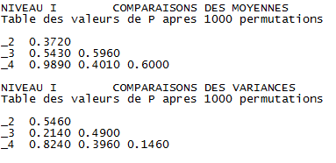

**7. Metric Disparity with COV**

1. Open the COV package of CLIC
2. Select “One subdivided matrix”-> “Sub-Matrix: Metric disparity of shape”
3. Select your raw, scaled data file.
4. You will be asked for grouping information:  
   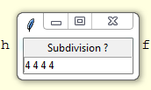
5. And number of bootstraps (1000):  
   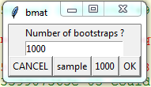
6. Then click “Save report?” and you will get a file titled: *Coord_MonthDay_scaled-raw_INFO_COVmd.txt*. This has the results of your MD calculation.
7. This file will conduct metric disparity on each grouping and then overall groupings (ie. 4 matrices of 4 individuals and the 5th matrix of 16 individuals)  
   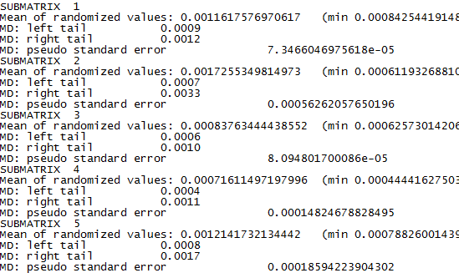
8. Look at your MD values and the pseudo standard errors.

**8. PCA with COV**

1. A PCA will help to see if the shape variation data can be grouped by some of your independent variables.
2. Open the COV package of CLIC
3. Select “Single matrix->PCA on convariance matrix” and open your *Coord_MonthDay_PW.txt* file.
4. The first graph you will see will look pretty bland:  
   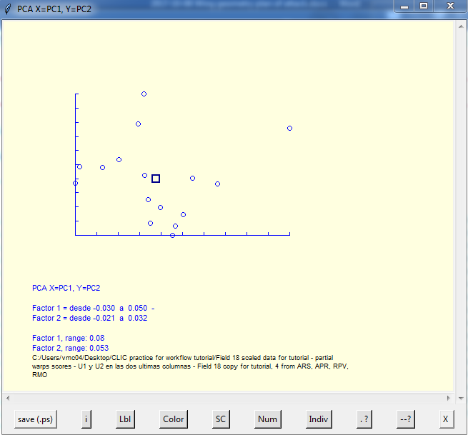
5. You can change colors by selecting the “Color” tab and entering your grouping information.  
   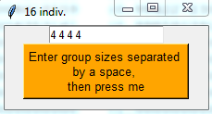
6. You get a different graph that you can customize. Just mouse over the buttons and information on each function will appear. You can select “SC” to select colors. You can select “OG” if you have other grouping information you want to see in your data.  
   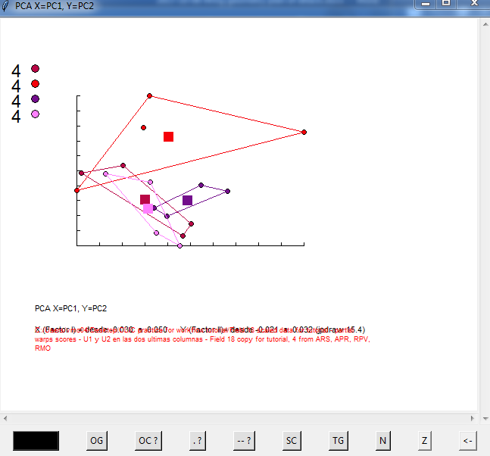
7. The text output in the COV space lists the different values for each PC. This example PCA has 31.8% explained by PC1 and 17.8% explained by PC2.
8. You can then click “Save report?” and screenshot your PCA graph. Your results will be in the file labeled *Coord_MonthDay_PW_INFO_COVpca.txt*

**9. Tree analysis with COV**

1. Open the COV package of CLIC (don’t close this session until you get to the end)
2. Select “One subdivided matrix->Sub matrix: Descriptive statistics” and open your *Coord_MonthDay_PW.txt* file.
3. Enter the appropriate groupings:
4. Scroll down and click the Euclidean distances and save. Then rerun to get the Procrustes distances:  
   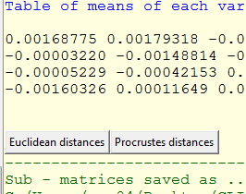
5. You will end up with a couple of files, the most important being the *…_PW_EUCLIDphylip* and *…_PW_PROCRUSTESphylip.txt*.
6. On the top bar of COV, select “External Software->neighbor (PHYLIP)”. Open the recent *…_PW_PROCRUSTESphylip.txt* that you created.
7. Respond to the prompts as “_ R > Enter > Choose UPGMA or NJ – L --->Yes, Yes, Enter”